List of IDOC we received in SPASS
- ZDK3A1
- ZDK3L1
- ZDK3P1
- ZDK3P2
- IOAPYRAMIDS
- CLFMAS
- BOMMAT
- BMUMAS
IDoc Failure and Processing Explanation
- In some cases, the IDoc fails initially and an incident is raised. However, after some time (for example, after a day), the same IDoc gets processed automatically and successfully.
- This happens because newly created materials are distributed from MABAS to COBALT through multiple message types. The processing depends on the sequence of jobs. If the jobs run in the correct sequence, the IDoc is processed successfully. If the sequence is not maintained, the IDoc may fail.
- Example:
- When a new material is created and distributed to the target system, the material availability job runs only after all the required master data is transferred.
- If the initial master data IDocs (such as CLFMAS, ZDK3PL, BOMMAT) fail, it may be due to:
- Material not existing in the target system, or
- Material not being fully activated
- In such cases, once the prerequisite data is available, the IDoc gets processed automatically.
- If required, we manually redistribute the material, after which the IDoc is processed successfully.

ZDK3A1, ZDK3L1,ZDK3P1 & ZDK3P2 :
Error : The alternative units of measure are inconsistent
Need to check : check the unit of measure views in both the ZD4 & Z2L systems. There will be mismatch in UOM’s or Compare the numerator and denominator values in both the systems.We will send mail to data changed by some user already or material owner.c
IOAPYRAMIDS :
Error : The material not exist or is not activated
Need to check : Firstly need to check the material whether it’s available in both systems or not then if the material is not available in the z2l means then need to distribute to cobalt system.
CLFMAS :
Error : Inconsistent characteristic value assignment
Type 1:
Need to check : Batch class once assigned to a material should not be changed, if changed then it is considered as an error.
Some time there will be inconsistency in the MABAS system then open the material in MM02 transaction go to classification view click on the Inconsistency and delete the inconsistent characteristic save it.

Type 2:
Use type: Value " INDUSTRIAL " not found
- While checking the above error in materials in classification view material class“001” in that FE00_EU_PCN below characteristics description value use type is maintained as “INDUSTRIAL” and Main intended use category” PAINT REMOVERS, THINNERS AND R” in ZD4 system.
- The classification is not available in z2l system.

- We try to click the drop down in the use type value “Phrase INDUSTRIAL does not exist”
“Phrase PAINT REMOVERS, THINNERS AND R does not exist”

- So phrase key with code is wrongly assigned to material and this also manually created by the user CCHACON on 12.08.2022.Because of this material not distributed to z2l system.
- To resolve the issue ask user to maintain the correct Professional with BAS01-HPK76678: 3862: Industrial and
BAS01-HPK76122: PC-PNT-7: Paint removers, thinners and related auxiliaries

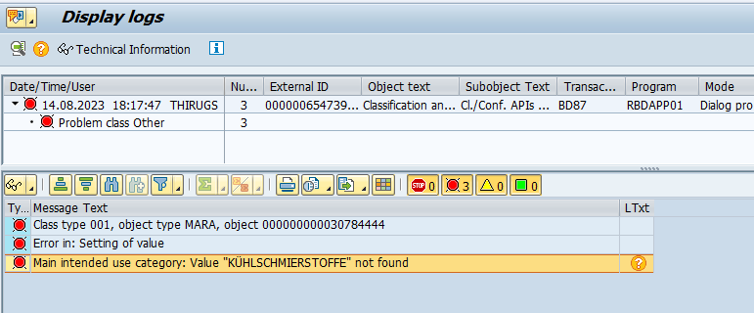
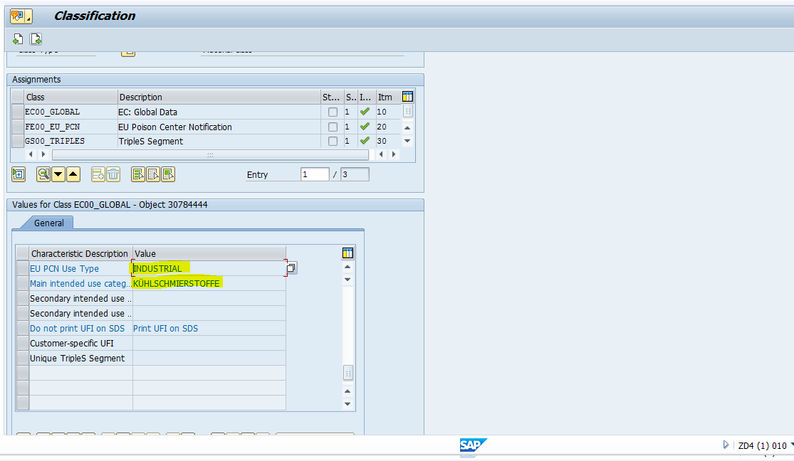
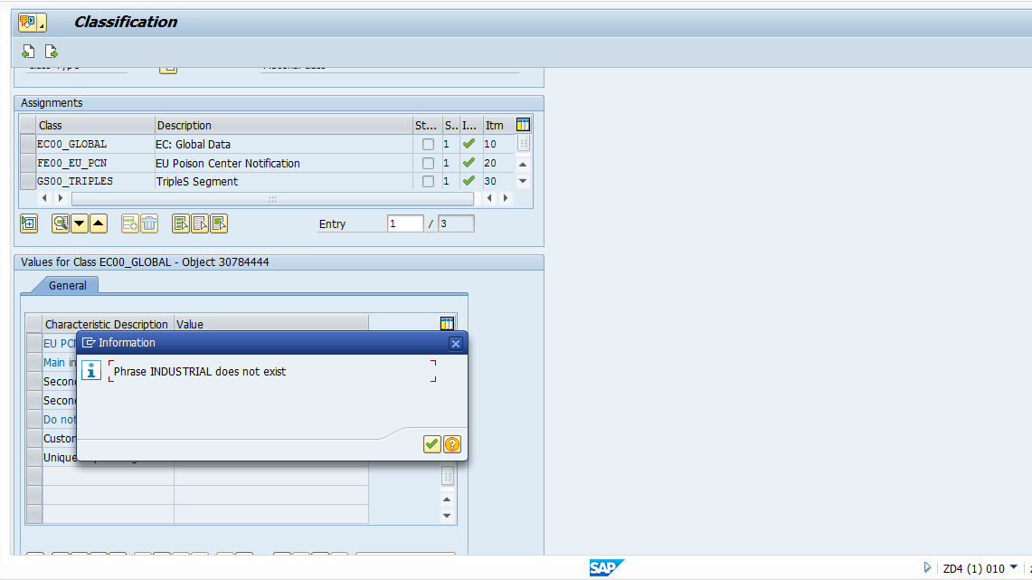
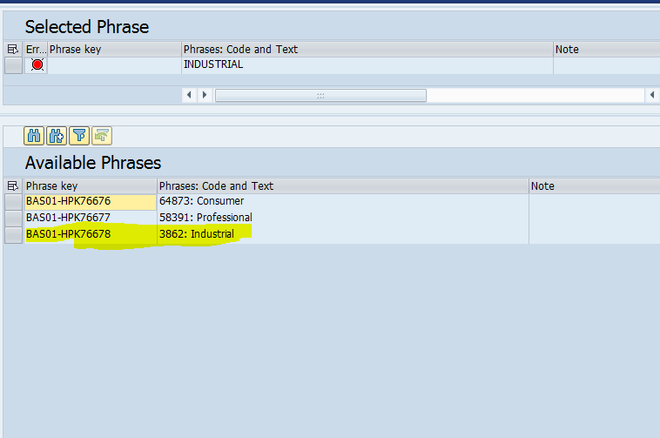

BOMMAT :
Error : Error when saving BOM. Please see the application log
Need to check : material components quantity should not be “0”. It should be some value.(CS03 transaction).

Analysis 1 –
Please follow below steps to rectify this issue

- Please assign the distribution list for the BOM component.
- Distribute the component to Cobalt system.
- Now distribute the material to Cobalt system

Step 1 -
Material 50854509 has component 11185334. For this component Assign the distribution list for the component. Later distributed component to cobalt system.
T-codes /n/BASF/MDMV_02, /n/BASF/MDMV_04
Step 2 -
Now distributed the Material 50854509 to cobalt system.
Analysis 2 :
After following the above analysis if still the material is generating the error idoc means
Once check the material component quantity in cs03 transaction
If the quantity is zero(0) need to change the quantity with the help of material owner then
the material will distribute successfully without error.

Analysis 3 :
In case BOMMAT IDOC’s which have been created for an ART , we need to first analyse for what reason the IDOC was created. In cases like this if the BOMMAT IDOC fails to process in the ERP system because the VERP for that ART is deleted (Z6) in the target system, we can set such BOMMAT IDOC’s to 68 status.
BMUMAS :
Error : Material is used in packing instructions
Need to check : material was maintained in Z2L system under PACKPO table due to this idoc is not processed.In order to processes the idoc kindly remove the material from z2l system.

